PART 13: ADJACENT TOURIST ATTRACTIONS.

General. Millions of visitors flock to the District of Columbia. Mall Rangers should know something about area attractions in order to provide the best possible Visitor Services. Many attractions vary their hours of operations based upon the season: Summer (generally Memorial Day through Labor Day) and Winter (generally the day after Labor Day through the day before Memorial Day). Many D.C. area attractions also have different ticketing systems for each season.

SITES | SUMMER | WINTER | PHONE | FEE | METRO
Aquarium | DAILY 9:00-5:00 |  | 202-482-2825 | $ | Fed. Triangle
Archives | DAILY 10:00-9:00 |  | 202-501-5400 |  | Archives
Arlington House (Robert E. Lee Memorial) | DAILY 9:30-4:30 |  | 703-557-0613 | $ Pkng. | Arlington Cem.
Arlington National Cemetery | DAILY 8:00-7:00 (Changing Of The Guard Every Half Hour) | DAILY 8:00-5:00 (Changing Of The Guard Every Hour) | 703-607-8052 | $ Pkng. | Arlington Cem.
Botanical Gardens |  |  | 202-225-7099 |  | Fed. Center, SW
Bureau of Engraving & Printing | MTWRF 9:00-1:40 Tickets Required. Ticket Booth Opens At  8 AM | MTWRF 9:00-1:40 No Tickets Needed Labor Day - Memorial Day | 202-874-3019 |  | Smithsonian
Capitol | DAILY 9:00-8:00 Tickets Required. Ticket Booth Opens At 9 AM. | DAILY 9-4:30, CLOSED Thanksgiving, Christmas, New Year's | 202-225-6827 |  | Capitol South
Children’s Museum | DAILY 10:00-5:00 |  | 202-675-4120 | $ | Union Station
Corcoran Gallery Of Art | MWFSS 10:00-5:00 Closed Tuesdays |  | 202-639-1700 | $ | Farragut W.
DAR Museum | MTWRF 8:30-4:00 Guided Tours 10 AM-2:30 PM. No Tours On Sundays |  | 202-879-3254 | $ | Farragut W.
Decatur House | TWRF 10:00-3:00 S & S 12:00-4:00 |  | 202-842-0920 | $
FBI | MTWRF 8:45-4:15 One Hour Tour. Leave Every 15-20 Minutes (First Come) |  | 202-324-3447 |  | Metro Center
Ford’s Theatre | DAILY 9:00-5:00 May Be Closed For Rehearsals & Performances |  | 202-426-6924 |  | Metro Center
Frederick Douglass Home NHS | DAILY 9:00-4:00 Tours 10 AM - 3 PM |  | 202-426-5960 | $ | Anacostia
Kennedy Center | DAILY 10:00-12Mid Tours Given From 10 AM – 4:30 P.M. Except For Sat. & Sun. 10 AM – 1:00 PM |  | 202-416-8341 |  | Foggy Bottom-GWU
Library of Congress | MTWRFS 10:00-5:30 Call Ahead For Tour Times. Closed On Sundays |  | 202-707-8000 |  | Capitol S.
Mount Vernon | DAILY 8:00-5:00 |  | 703-780-2000 | $ | Huntingdon
National Building Museum | MTWRFS10:00-5:00 SUN 12:00-5:00 |  | 202-272-2448 |  | Judiciary Square
National Cathedral | DAILY 10:00-3:15 Call Ahead For Tour Times. |  | 202-537-6207
Old Post Office Tower | DAILY 8:00-10:45 |  | 202-606-8691 |  | Federal Triangle
National Gallery of Art | MTWRFS 10:00-5:00 SUN 11:00-6:00 |  | 202-737-4215 |  | Archives-Navy Memorial
National Geographic Society | MTWRFS 9:00-5:00 SUN 10:00-5:00 |  | 202-857-7588 |  | Farragut North
National Law Enforcement Officer’s Memorial | DAILY 24 Hr. |  | 202-737-3400 |  | Judiciary Square
National Museum Of Women In The Arts | MTWRFS10:00-5:00 SUN12:00-5:00 |  | 202-783-5000 | $ | Metro Center
Navy Memorial Visitor Center | MTWRFS 9:30-5:00 |  | 202-737-2300 |  | Archives-Navy Memorial
Newseum | TWRFSS10:00-5:00 |  | 703-284-3544 |  | Rosslyn
Octagon House | TWRFSS 10:00-4:00 Tours On The Hour Every Hour |  | 202-638-3221 | $
Old Executive Office Building | SAT Only 8:30-12Noon Tour Reservations Required. |  | 202-395-5895 |  | McPherson Square
Pentagon | MTWRF 8:45-3:00 90 Min. Walking Tour Every Hr., Need Photo ID |  | 703-695-1776 |  | Pentagon
President’s Park White House Tours | TWRFS 10:00-12 Noon AM (WH Visitor Center 7:30-3:00) | TWRFS 10:00-12 Noon Tickets Not Required. Line Forms S.E. Ellipse. | 202-456-7041 (White House Visitor Center 202-208-1631) |  | McPherson Square
Smithsonian Institution
Arthur M. Sackler (Asian) Gallery | DAILY 10:00-5:30 |  | 202-357-2700 |  | Smithsonian
Arts & Industries Building | DAILY 10:00-5:30 |  | 202-357-2700 |  | Smithsonian
Freer Gallery Of Art | DAILY 10:00-5:30 |  | 202-357-2700 |  | Smithsonian
Hirshorn Museum & Sculpture Garden | DAILY 10:00-5:30 |  | 202-357-2700 |  | Smithsonian
National Air & Space Museum | DAILY 9:30-6:00 |  | 202-357-2700 |  | Smithsonian
National Museum of African Art | DAILY10:00-5:30 |  | 202-357-2700 |  | Smithsonian
National Museum of American Art-CLOSED FOR RENOVATION |  |  |  |  | Gallery Palce-Chinatown
National Museum of American History | DAILY 10:00-7:30 |  | 202-357-2700 |  | Smithsonian
National Museum of Natural History | DAILY 10:00-7:30 |  | 202-357-2700 |  | Smithsonian
National Portrait Gallery-CLOSED FOR RENOVATION
National Postal Museum | DAILY 10:00-5:30 |  | 202-357-2700 |  | Union Station
National Zoo | DAILY 8:00-6:00 |  | 202-673-4717 |  | Woodley Park-Zoo
Renwick Gallery | DAILY 10:00-5:30 |  | 202-357-2700 |  | Farragut West
CASTLE | DAILY 9:00-5:30 |  | 202-357-2700 |  | Smithsonian
State Department | MTWRF Reservation Required For 9:30, 10:30 & 2:45 Tours. Photo Id Required. |  | 202-647-3241 |  | Foggy Bottom-GWU
Supreme Court | MTWRF9:00-4:30 Courtroom Lectures Every Hour On The Half Hour From 9:30-3:30 (Except When In Session) |  | 202-479-3211 |  | Capitol South
Treasury Department | SAT Only 10:00-11:00 Tour Reservations Required. |  | 202-622-0896 |  | McPherson Square
U.S. Holocaust Memorial Museum | DAILY 10:00-5:30 Ticket Office Opens AT 10 AM On 14th St. To Pick Up Free Same-Day Tickets (Permanent Exhibit) Advance Tickets ($), Call PROTIX 1-800-400-9373 |  | 202-488-0400 |  | Smithsonian

Commonly Visited Government Buildings.

White House. (From official website)
The White House, one of the most recognizable buildings in Washington, DC,
was designed by James Hoban, an Irish-born and-trained architect who won a competition organized by President George Washington and Secretary of State Thomas Jefferson in 1792. The competitions were held to determine who would design the nation's two most important buildings, the President's House and the Capitol. It is believed that Jefferson, competing under a pseudonym, submitted designs and lost both competitions. Hoban's inspiration for the house was drawn from an Anglo-Irish villa called the Leinster House in Dublin.

Although President Washington oversaw construction, he never lived in the house. President John Adams, elected in 1796 as the second President, was the first resident of the White House. Abigail Adams, President Adams' wife, was known to have complained about the largely unfinished new residence. President Thomas Jefferson, upon moving to the house in 1801, was also not impressed, and dismissed the house as being too big. Jefferson made several structural changes under architect Benjamin Henry Latrobe such as the addition of terrace-pavilions on either side of the main building and single-story wings for storage. In addition to replacing the slate roof with one of sheet iron, Jefferson further improved the grounds by landscaping them in a picturesque manner.

While James Madison was President from 1809 to 1817, the White House was torched by the British in the War of 1812. Although the fire was put out by a summer thunderstorm, all that remained were the outside, charred walls and the interior brick walls. Madison brought Hoban back to restore the mansion, which took three years. It was during this construction that the house was painted white. Hoban later added the South and North Porticos, using a slightly altered design by Latrobe.

Expansion and further alterations were made when President Theodore Roosevelt declared the house unsafe to inhabit. He had the original building remodeled. By making the third-story attic into habitable rooms and adding the Executive Office wing and the East Gallery, Roosevelt separated his work space from his family life. In 1909, architect Nathan C. Wyeth extended the office wing adding the well-known oval office. Although used informally for some time, it was President Theodore Roosevelt who gave the White House its official name. Finally, the last major renovation took place when President Harry Truman decided that again the building was unsafe and had to be gutted. Steel replaced the original frame and paneling, and a balcony was added to the South Portico. The White House, an architectural symbol of the American presidency and the nation's power, remains a stylistically simple residence and an example of the stolid republican ideals of the Founding Fathers.

The White House is located at 1600 Pennsylvania Ave., NW. Free tours are offered, but schedules change with little notice due to official events. Self-guided public tours are scheduled Tuesday through Saturday, 10:00 am to 12:00 pm. The National Park Service distributes tickets in the White House Visitor Center, located at 15th and E Streets., NW. Visitors should confirm tour times for specific days. The Visitor's Office Information Line is (202) 456-7041. The nearest Metro stop is McPherson Square.

United States Capitol. (From official website). The United States Capitol is among the most symbolically important and architecturally impressive buildings in the nation. It has housed the meeting chambers of the House of Representatives and the Senate for two centuries. The Capitol, which was started in 1793, has been through many construction phases. It stands today as a monument to the American people and their government.

An example of 19th-century neoclassical architecture, the Capitol evokes the ideals that guided the Founding Fathers as they developed the new republic. Pierre Charles L'Enfant was expected to design the Capitol, but his dismissal in 1792 due to his refusal to cooperate with the Commissioners of the Federal Buildings, resulted in other plans. A competition was suggested by Secretary of State Thomas Jefferson and President George Washington that would award $500 and a city lot to whomever produced the winning plan by mid-July. None of the 17 plans submitted were satisfactory. In October, a letter arrived from Dr. William Thornton, a Scottish-trained physician living in the British West Indies, requesting an opportunity to submit his plan after the competition was closed. The Commissioners granted his request and President Washington commended the plan that was soon accepted by the Commissioners.

The cornerstone was laid by President Washington on September 18, 1793. Because of Thornton's inexperience, the initial work progressed under the direction of three architects in succession. Stephen H. Hallet and George Hadfield were dismissed because of inappropriate design changes they tried to impose; James Hoban, winner of the competition for the President's House, was placed in charge and saw to the completion of the north wing for the first session of Congress on November 17, 1800. In 1803, construction resumed under Benjamin Henry Latrobe who completed the south and north wings. By 1813, Latrobe, with his job done, departed with the wings connected by a temporary wooden passageway.

On August 24, 1814, British troops set fire to the building during the War of 1812. A rainstorm prevented its complete destruction and Latrobe returned to Washington in 1815 to make repairs. He took this opportunity to make changes to the building's interior design and to introduce new materials, such as marble. Latrobe, however, resigned his post in November of 1817 because of construction delays and increasing costs. Charles Bulfinch, a Boston architect, was appointed Latrobe's successor in January of 1818. Continuing the restoration, he was able to make the chambers of the Senate and House, as well as the Supreme Court, ready for use by 1819. Bulfinch redesigned the central section, making the dome that topped the section higher. Bulfinch spent his last couple of years on the Capitol's landscaping and decoration until his position was terminated in 1829.

By 1850, the Capitol could no longer accommodate the increasing numbers of senators and representatives. Another competition was held offering $500 for the best plan to extend the Capitol. Unable to decide between the plans, Congress divided the money between five architects and Thomas U. Walter was chosen to complete the task. Walter supervised the construction of the extensions, making sure they were compatible with the existing style of the building, but using marble for the exterior instead of sandstone, which deteriorates quickly. As the wings progressed, they more than doubled the length of the Capitol making the dome too small for the new proportions. In 1856, the old dome was removed and work began on a replacement with a new, fireproof cast-iron dome. Construction was suspended in 1861 so that the Capitol could be used as a military barracks, hospital and bakery for the Civil War. However, in 1862, construction resumed, because Lincoln believed that the Capitol must go on, just as the Union must go on.

The work on the dome and extensions was completed in 1868 under Edward Clark, who had served as Walter's assistant until his resignation in 1865. Clark held the post of Architect of the Capitol until his death in 1902. Considerable modernization occurred during his tenure, as well as the construction of the marble terraces on the north, west, and south sides of the Capitol. The terraces were constructed as part of the grounds plan devised by landscape architect, Frederick Law Olmsted. After a fire in November 1898, the need for fireproofing became evident. Elliot Woods, Clark's successor, saw to the reconstruction and fireproofing of the damaged wing.

The 20th century has seen even further changes for the Capitol. Under the direction of J. George Stewart, the appointed Architect of the Capitol, the East front extension added 102 more rooms from 1959 to 1960. The stonework was also changed from sandstone to Georgia marble during the process. After a public protest at further plans to expand in the 1970s, the plans were dismissed and the vote went to restore, rather than enlarge, the West Front. Since then, primary emphasis has been on strengthening, renovating and preserving the building.

Today, the Capitol covers a ground area of 175,170 square feet and has a floor area of about 16.5 acres. In addition to its use by Congress, the Capitol is a museum of American art and history. It stands as a focal point of the government's legislative branch and as a centerpiece of Capitol Hill and the National Mall.

The Capitol is located on Capitol Hill at the east end of the National Mall. The Capitol is open to the public every day of the year except for New Year's Day, Thanksgiving Day and Christmas Day. March through August, hours are 9:30 am to 8:00 pm and September through February, hours are 9:00 am to 4:30 pm. Tours are free and tickets are not required for entry. For further information, please call 202/225-6827. Metro stop: Capitol South

The Statue of Freedom. Many visitors to the Washington Monument will ask about the statue on top of the Capitol. The following description is taken from the Web Page of the Architect of the Capitol:

The bronze Statue of Freedom by Thomas Crawford is the crowning feature of the dome of the United States Capitol. The statue is a classical female figure of Freedom wearing flowing draperies.

Her right hand rests upon the hilt of a sheathed sword; her left holds a laurel wreath of victory and the shield of the United States with thirteen stripes. Her helmet is encircled by stars and features a crest composed of an eagle's head, feathers, and talons, a reference to the costume of Native Americans. A brooch inscribed "U.S." secures her fringed robes. She stands on a cast-iron globe encircled with the national motto, E Pluribus Unum. The lower part of the base is decorated with fasces and wreaths.

Ten bronze points tipped with platinum are attached to her headdress, shoulders, and shield for protection from lightning. The bronze statue stands 19 feet 6 inches tall and weighs approximately 15,000 pounds. Her crest rises 288 feet above the east front plaza.

A photograph of the statue and information about the October 1997 maintenance of the statue are also available from the Architect of the Capitol.

A monumental statue for the top of the national Capitol appeared in Architect Thomas U. Walter's original drawing for the new cast-iron dome, which was authorized in 1855. Walter's drawing showed the outline of a statue representing Liberty; Crawford proposed an allegorical figure of "Freedom triumphant in War and Peace." After Secretary of War Jefferson Davis objected to the sculptor's intention to include a liberty cap, the symbol of freed slaves, Crawford replaced it with a crested Roman helmet.

Crawford was commissioned to design the Statue of Freedom in 1855 and executed the plaster model for the statue in his studio in Rome. He died in 1857 before the model left his studio. The model, packed into six crates, was shipped from Italy in a small sailing vessel in the spring of 1858. During the voyage the ship began to leak and stopped in Gibraltar for repairs. After leaving Gibraltar, the ship began leaking again to the point that it could go no farther than Bermuda, where the model was stored until other transportation could be arranged. Half of the crates finally arrived in New York in December, but all sections were not in Washington until late March of 1859.

Beginning in 1860, the statue was cast in five main sections by Clark Mills, whose bronze foundry was located on the outskirts of Washington. Work was halted in 1861 because of the Civil War, but by the end of 1862 the statue was finished and temporarily displayed on the Capitol grounds. The cost of the statue, exclusive of installation, was $23,796.82. Late in 1863, construction of the dome was sufficiently advanced for the installation of the statue, which was hoisted in sections and assembled atop the cast-iron pedestal. The final section, the figure's head and shoulders, was raised on December 2, 1863, to a salute of 35 guns answered by the guns of the 12 forts around Washington.
The plaster model of the statue, which had been in storage for 25 years, was reassembled and restored in the basement rotunda of the Russell Senate Office Building, where it was returned to permanent public display in January 1993.

On May 9, 1993, after almost 130 years in place, the bronze statue was removed from its pedestal by helicopter for restoration. The work was needed because of extensive pitting and corrosion on the surface of the bronze and because of a crack and rusting on the cast-iron pedestal. The project was guided by the recommendations of a thorough conservation and engineering study conducted in 1991. The United States Capitol Preservation Commission provided $780,000 in privately raised funds, which covered all project costs.

The disfiguring caulk and much of the corrosion were removed by water blasted at medium pressure. Repairs to the statue included the insertion of over 700 bronze plugs in the most significant pits; bronze patches were also inserted where needed. Rusting original iron elements and the interior paint were removed. The bronze, which varied in composition and condition, was painstakingly repatinated to the "bronze green" noted in early records. Finally, layers of acrylic lacquer and wax were applied to protect the surface against further corrosion, and small gaps were sealed with caulk.

The cast-iron pedestal was restored in place atop the dome. The metal was stripped of paint, and the wreaths and fasces were removed to ensure that they were thoroughly cleaned and coated. The crack was permanently repaired, and the entire pedestal was primed and painted with a color specially mixed to match the statue.

Restoration of the statue and the pedestal was completed in approximately four months. The Statue of Freedom was returned to its pedestal by helicopter on October 23, 1993, amidst the congressional celebration of the bicentennial of the U.S. Capitol.

Other Popular Federal Structures Adjacent to Our Sites.

Arlington Memorial Bridge. Crosses Potomac River at Lincoln Memorial to Arlington National Cemetery, Virginia.
Architects McKim, Meade & White.
The bridge symbolizes the binding together of the North and the South in one great Union. It was constructed by the Arlington Memorial Bridge Commission and the Department of the Interior at a cost of $14,750,000. Dedicated January 16, 1932. (43 Stat. 974)

Arts of Peace, Arts of War Equestrian Statues. You can find these on the eastern end of Memorial Bridge Plaza and Rock Creek Parkway approach. James Fraser and J.H. Friedlander created the designs. These bronze statue groups of horses and figures were cast in Italy as a gift from Italy to the United States. These are surfaced with pure gold. The groups symbolize the Arts of Peace (Aspiration and Literature) by Fraser and the Arts of War (Valor and Sacrifice) by Friedlander. Dedicated September 26, 1951.

Ford’s Theater and Peterson House. (From website, http://www.nps.gov/foth) Ford's Theatre NHS is the site of the nation’s first presidential assassination. An unemployed actor angered by President Lincoln’s war policies, and the Confederacy’s recent failures in the war decided to take things into his own hands. Using the familiar ground of the theater, John Wilkes Booth entered the theatre on the night of April 14, 1865 and shot the President in the back of the head.

Following the shooting, the President was carried across the street to the Petersen House where he was placed in a bed. Doctors attended the President through the night but he never regained consciousness. Lincoln died the next morning about 7:22 a.m. in the back bedroom of the rooming house.

Today, the National Park Service and Ford’s Theatre NHS preserve the site of this tragic event. Park rangers give talks recounting the details of the assassination. In addition, the events of that evening are interpreted through the display of objects associated with the assassination located in the museum in the basement of the building. The Petersen House (The House Where Lincoln Died), across the street from the theater, has been preserved and historically furnished to depict the scene of that night.

Ford's Theatre preserves the memory of Lincoln and the assassination, and through the work of Ford's Theatre Society and its professional productions, Lincoln’s love of the theater stays alive.

Tours at Ford's Theatre are free and self-guided. The theatre is normally open between the hours of 9AM and 5PM. Being an active stage, the theatre closes at times for matinees and rehearsals. During hours of operation when the theatre is closed, the museum and House Where Lincoln Died usually remain open to our visitors. Spring at Ford's Theatre NHS - School groups and others come in great numbers to tour the site of Lincoln's Assassination during the March through July tour season. Nearly 70% of Ford's visitors came during the months of March through July in 1999.
The talks are fifteen minutes long and cover the history of the assassination and the theatre. Talks are given daily at the following times:

9:15 a.m.
10:15 a.m.
11:15 a.m.
12:15 p.m.
1:15 p.m.
2:15 p.m.
3:15 p.m.
4:15 p.m. (last talk of the day)

Ford's Theatre NHS continues to present plays and entertainment to the public; consequently, there are times when tours are not permitted in the theater. If you would like to see the theater during your visit please check our calendar for any closings. For the most current information about our public tour schedule please call 202-426-6924.

Old Post Office Tower. (from website, http://www.nps.gov/opot). Pierre L'Enfant, the French born engineer selected by George Washington in March 1789 to plan the new national capital, envisioned a "Grand Avenue" connecting the "President's House "and the "Congress House." The two most important buildings of the Federal government would operate within sight of each other. He hoped to line the street with academies, lecture halls and other institutions "of such sort as may be attractive to the learned and afford diversion to the idle."

However, L'Enfant's ideal is not what developed. By the middle of the 19th Century, hotels and boarding houses were scattered along the north side of the avenue. The area to the south was known as Murder Bay, one of the most notorious slums in Washington. Between 1836 and 1869, the new Treasury Department Building was constructed with its south facade extended into the Pennsylvania Avenue right of way. L'Enfant's layout with the view of the Capitol from the White House was irrevocably altered.

In 1880, Congress attempted to revitalize the Murder Bay area by authorizing the construction of a combined United States Postal Department and District Post Office building. The hope was that erecting an impressive edifice would entice others to invest in the area. The Federal Post Office building was the first steel-frame building constructed in Washington. The frame was covered with a massive granite exterior designed in the Richardsonian Romanesque style of architecture.

When completed, it was the largest federal office building in the city and its great glass-covered atrium of 99 by 184 feet is still one of the largest unobstructed open spaces in any federal building. It was the first building in Washington to have its own power plant, producing enough electricity to light 3,900 light bulbs. The immense 315 foot high clock tower was second in height only to the Washington Monument. The American people could be proud of such a magnificent building. However, soon this grand architectural monument would be locked in a struggle for survival that would last for more than seven decades.

When completed in 1899, it was thought that the Post Office Building would stimulate revitalization of one of the worst neighborhoods in Washington, DC. It became evident that the hoped-for results were not forthcoming. The early years of the building's history were marked with controversy and disappointment. The Old Post Office Building was less than ten years old when cries were heard that it should be torn down. One local man, Nathan Rubinton, carved by hand a model of the building so that when it was torn down people would remember how it looked. In 1914, the District of Columbia Mail Depot was moved to a larger building constructed next to Union Station. Although only 15 years old, the building at 12th Street and Pennsylvania Avenue was dubbed the "old" post office.

The Postmaster General moved to a newly constructed office building directly across 12th Street in 1934. The only reason that the Old Post Office was not then razed was a lack of money due to the Great Depression. For the next 40 years the building served as overflow space for several government agencies. In the 1970s, Congress finally appropriated the money to remove the Old Post Office. Local citizens banded together for a desperate final struggle to save it. Nancy Hanks, the politically influential chairperson of the National Endowment for the Arts, joined the effort and prevailed in convincing Congress to reverse its decision: the Old Post Office was rescued. In 1983, the Old Post Office was officially renamed the Nancy Hanks Center in recognition of her devotion to the arts and the preservation of architecturally significant buildings.

After years of renovation, the Old Post Office reopened. Today, both government and privately owned businesses share its generous spaces. Daily, thousands of visitors and government workers enjoy the food courts, shopping, and entertainment on the stage. The National Park Service provides tours of the Old Post Office Tower affording one of the most spectacular views of Washington from the 270 foot-high observation deck. An exhibit room depicts the struggle for survival of the Old Post Office building and features the Rubinton model. While touring the tower, visitors can also view the Congress Bells, one of the largest sets of change ringing bells in North America and the official bells of the United States Congress.

Smithsonian Museums. Upon his death in 1829, the estate of James Smithson, Duke of Northumberland, passed to his nephew, and faling an heir by him, to the United States in order to found “an establishment for the increase and diffusion of knowledge. Six years later, his nephew died. The huge collection of Smithsonian Institution museums we see along the Mall today arose from the original bequest.
Smithsonian Institution Building . The “Castle” houses the Smithsonian Information Center.

Arts and Industries Building. Changing exhibitions for Center for African American History and Culture 150 Years of Collecting (includes items from 1876 Centennial exhibition) Discovery Theater (for children).

National Air & Space Museum. History, science, and technology of aviation and space flight. Exciting aviation films are shown on a spectacular IMAX screen evoking a breathtaking sense of flight. There is an admission fee for the films.

National Museum of American History. History of science, technology, and culture in America. Many American inventions, whether related to farming, electricity, transportation, etc. can be found here.

National Museum of Natural History. History of the natural world and human cultures. See the 45.5 carat Hope Diamond, and other fantastic exhibits.

Arthur M. Sackler Gallery. Asian art from ancient times to the present.

Freer Gallery of Art. Asian art and 19th to early 20th-century American art.

National Museum of African Art. Collection, study, and exhibition of African Art.

Hirshhorn Museum and Sculpture Garden. Modern and contemporary art.

National Museum of American Art. Painting, sculpture, graphics, folk art, and photography; 18th century to the present, special exhibitions of American art.

Renwick Gallery of the National Museum of American Art. This gallery is devoted to the work of American crafts. It houses collections of design and decorative artists of the 20th century.

National Portrait Gallery. This museum contains more than 11,000 paintings, posters, photographs, prints, sculptures and drawings of men and women who have made significant contributions to the history, development and culture of the United States.

National Postal Museum. Located in the restored Washington, D.C. City Post Office Building, this museum houses the nation's postal history and philatelic collection and has more than 16 million objects to view.

Local Squares, Plazas, and Parks. The NPS administers many of the green areas within the District. Several are adjacent to the National Mall.
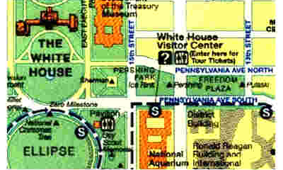
Freedom Plaza. Pennsylvania Avenue and 14th Street, NW. This broad flat surface is a nice place to rest between tour stops. One can study Pierre L'Enfant's original design for the National Capital that is marked out in colored concrete on the plaza surface.
Freedom Plaza

Pershing Park. West of Freedom Plaza, across 14th Street is Pershing Park, an oasis in the swirling traffic. Visitors will find the comfort of trees, shrubs, and water.

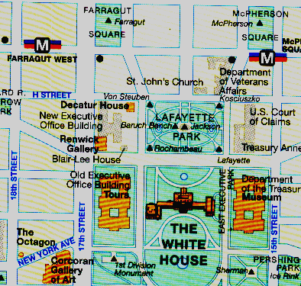
General John J. Pershing statue. An Act of Congress approved April 2, 1956 (P.L. 461) authorized the American Battle Monuments Commission to erect a memorial to General John Pershing. The statue was sculpted by Robert White.
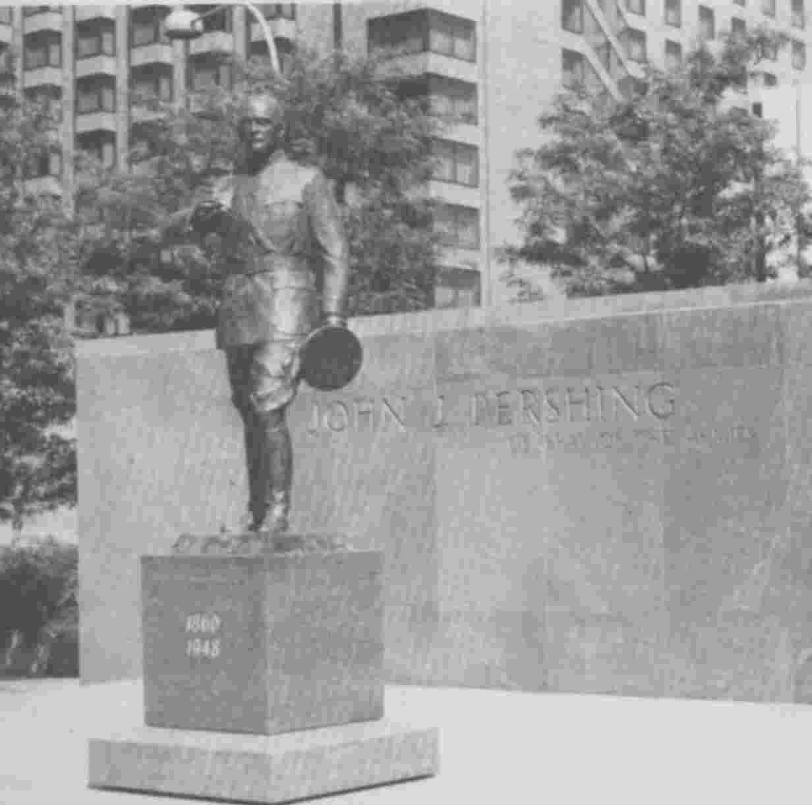
Pershing

The memorial was erected as a part of the Pennsylvania Avenue Development Corporation design of Pennsylvania Avenue in 1983 and has been included in the design of Pershing Square.

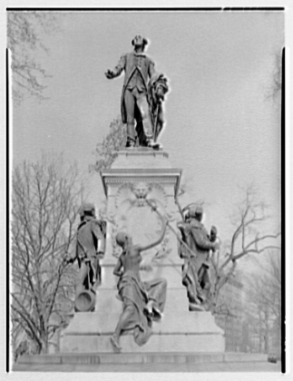
The Ellipse. This expanse is used for everything from the annual Christmas Pageant for Peace to ballgames and demonstrations. It contains the Boy Scout, Butt-Millet (local Titanic victims) and 2nd Division (WWI, WWII, and Korea) memorials, the Haupt fountains, The National Christmas Tree, and the Zero Milestone where, in 1919, the first trans-continental motor caravan started.

Lafayette Park . Directly north of the White House. In the center of the park is a statue of Andrew Jackson made from cannon he captured during the War of 1812. At the corners of the park are statues of Thaddeus Kosciuszko, baron von Steuben, the comte de Rochambeau, and the marquis de Lafayette. The bench where Bernard Baruch, adviser to Presidents, sat is also marked.

General Lafayette Statue, Lafayette Park, SE comer. Sculpted by Alexandre Falquiere and Antonin Mercie. The memorial to General Lafayette and compatriots is of bronze on a marble pedestal. On the east and west sides are bronze figures of Comte d'Estaing, Comte DeGrasse, Chevalier Duportail and Comte de Rochambeau.

Lafayette
On the south side is a bronze figure symbolizing America lifting up a sword to Lafayette. Erected by the government at a cost of $50,000 under an Act of Congress approved March 3, 1885 (23 Stat. 508). Completed April 1891.

General Kosciuszko statue. Lafayette Park, NE corner. By Antion Popiel. A bronze standing figure of General Kosciuszko, shown wearing a Continental Army uniform, is on a granite pedestal. He is holding fortification plans for Saratoga. Of Lithuanian origin, Kosciuszko came to America at the outbreak of the Revolutionary War and played an important part in many famous battles.

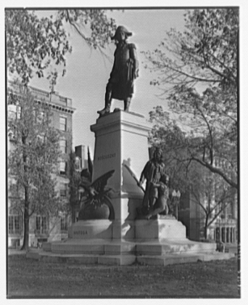
Kosciuszko

Erected by the Polish National Alliance of American and Polish American Citizens at a cost of $76,835, under an Act of Congress approved April 18,1904 (33 Stat. 588) which authorized $3,500 for preparing and improving the site. Dedicated May 11, 1910.

Bernard Baruch's Bench of Inspiration. Lafayette Park, Pennsylvania Ave. between Jackson & Madison Places, NW. A commemorative bench with a bronze plaque set in granite block in honor of the elder statesman on his 90th birthday. He advised many Presidents throughout the course of his life. The Bench of Inspiration was financed by the National Capital Area Council and Boy Scouts of America. Dedicated on August 16, 1960.

Count Rochambeau statue. Lafayette Park, SW. corner. Sculpted by M. Hamar of Paris. This bronze standing figure of Count Rochambeau, on a granite pedestal, is a replica of the one at Vendome, France, his birthplace.

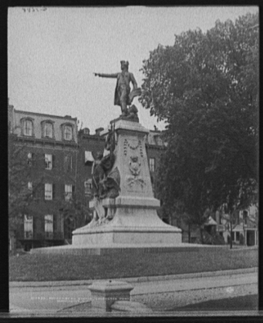
Rochambeau

His family insignia is on one side and the French coat of arms on the other. Rochambeau, noted French soldier, commanded the French force that was dispatched in 1780 to aid the Americans in the Revolution. He joined Washington's forces at White Plains, N.Y., and assisted in forcing Cornwallis' surrender at Yorktown.

Erected by the government at a cost of $22,500 under an Act of Congress approved March 3, 1901. Two Acts were approved in 1902 appropriating $20,000 for expenses of members of the French government, Rochambeau's family and General Lafayette's family to attend the dedication on May 24, 1902.

General (Baron) Frederick Von Steuben statue. Lafayette Park, Pennsylvania Ave. between Madison and Jackson Place (NW corner). By Albert Yaegers, this bronze standing figure of General Von Steuben shows him in the uniform of a Major General of the Continental Army. It is on a granite pedestal with bronze figure groups.

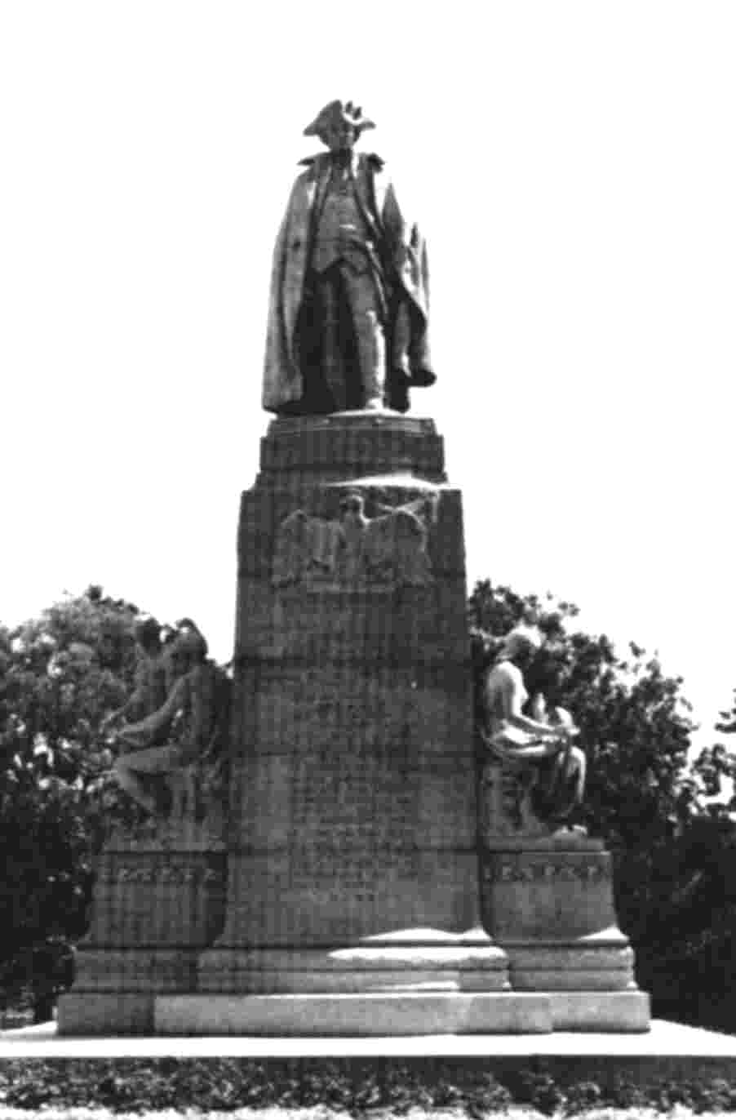
Von Steuben

Von Steuben was Aide-de-Camp to Frederick the Great and joined the American colonies in the Revolution to train the citizen-soldiers of America.

Erected by the government at a cost of $50,000 under an Act of Congress approved February 27, 1903 (32 Stat. 908). Dedicated on December 7, 1910.
President Andrew Jackson statue, by Clark Mills. Lafayette Park, Pennsylvania Ave. between Madison & Jackson Place. This bronze equestrian statue to Andrew Jackson, the 7th President of the United States, is cast from a bronze cannon captured at Pensacola during his last campaign against the Spanish in 1818.

The statue is remarkable for its perfect balance with a perfect center of gravity based in the charger's hind feet. The statue was Mills' first statue. Jackson achieved his greatest military fame at the Battle of New Orleans in 1815.

Erected by the government at a cost of $28,500 plus a contribution of $12,000 from the Jackson Democratic Association of Washington, D.C. under an Act of Congress approved August 11, 1848 (9 Stat. 340). Dedicated January 8, 1853.

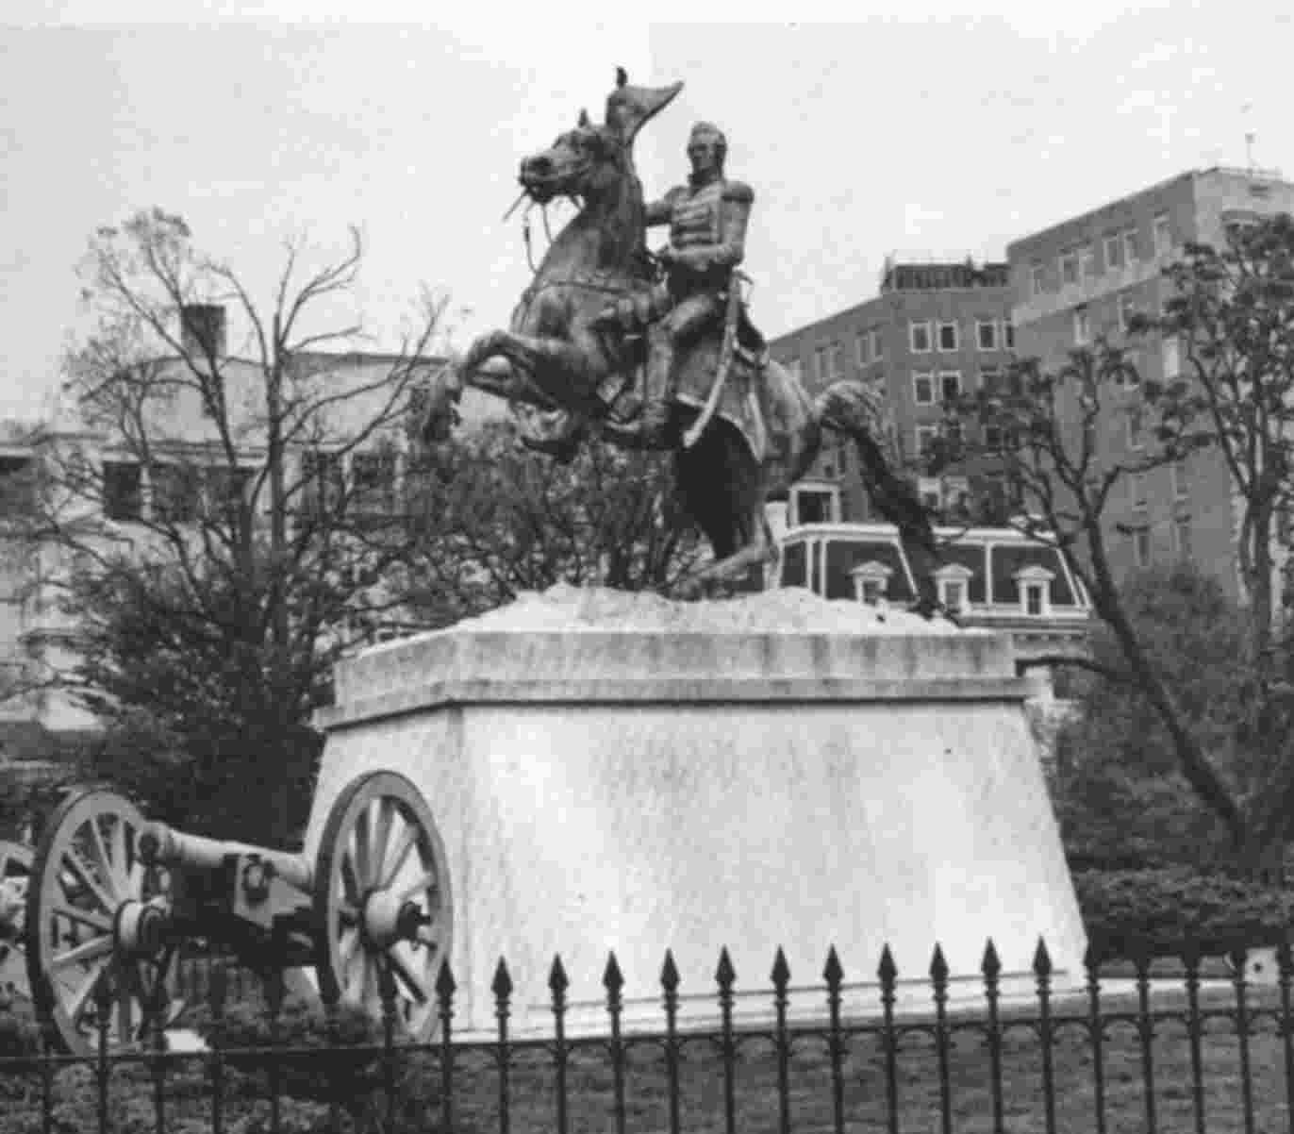
Jackson

